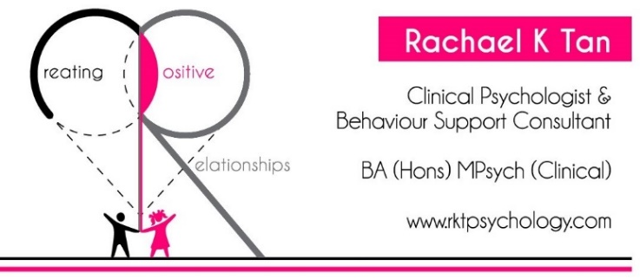

NDIS Participant Information & Referral Form

Storage, Access and Correction of Personal Information
RKT Psychology is bound by and adheres to the legal requirements and Australian Privacy Principles of the Privacy Act 1988 and the Privacy Amendment (Private Sector) Act 2000.

Participant Information
First and last name: | Click or tap here to enter text.
Preferred name: | Click or tap here to enter text.
Gender: | Click or tap here to enter text.
Date of birth: | Click or tap here to enter text.
Residential address: | Click or tap here to enter text.
Primary disability (Please also include other relevant diagnoses if applicable): | Click or tap here to enter text.
Key support people (please select all that apply): | ☐Parent(s) ☐Grandparents ☐Sibling(s)  ☐Paid support workers/carers ☐Other:
NDIS Participant number: | Click or tap here to enter text.
Current NDIS Plan start and end date: | Click or tap here to enter text.
The NDIS funds you will be using with RKT Psychology are: | ☐Plan-managed ☐Self-managed
*Please kindly attach a copy of the relevant section of the current NDIS Plan to this Referral.

Information of Representatives whom the Participant enlists to support with decision making (if applicable)
Name: | Click or tap here to enter text.
Relationship to Participant: | Click or tap here to enter text.
Residential address: | Click or tap here to enter text.
Contact number: | Click or tap here to enter text.
Email address: | Click or tap here to enter text.

Name: | Click or tap here to enter text.
Relationship to Participant: | Click or tap here to enter text.
Residential address: | Click or tap here to enter text.
Contact number: | Click or tap here to enter text.
Email address: | Click or tap here to enter text.

Referral Information
RKT Psychology requests this information from you to allow us to assess and determine if we are the best service to meet your required needs.

What is the issue you are seeking help for? (e.g., challenging behaviour, non-compliance, anxiety). Please be as specific as you can.
Click or tap here to enter text.

How long has this issue been happening for? (e.g., recently, following an event, for X number of years, since X age)
Click or tap here to enter text.

What strategies have you tried so far, if any?
Click or tap here to enter text.

Have you sought help for this issue before now? If yes, what kind?
Click or tap here to enter text.

What do you hope to achieve from therapy sessions? Please also include requirements stated in your NDIS Plan, in this section
Click or tap here to enter text.

Please include any additional information that you feel would be helpful for us to know
Click or tap here to enter text.

Does the Participant currently experience or engage in any of the following, that you are aware of? Please indicate YES or NO.
- Suicidal ideation:Click or tap here to enter text.
- Self-harm related to mental health difficulties:Click or tap here to enter text.
- Psychosis (history of or current):Click or tap here to enter text.
Privacy Statement and Declaration

Your personal information is protected by law (including the Privacy Act 1988) and is collected by RKT Psychology in order to assess and administer its disability support services. Your information may only be used by RKT Psychology or given to other parties where you have agreed to that, or where it is required or authorised by law. More information about how we manage your privacy is contained in our Consent Form, which can be requested at any time from RKT Psychology.

I have been informed and consent to the use of my information in the assessment and administration of my services. I understand that this information may be provided to external agencies where I have consented to this, or where it is required by law.

I declare that all of the information I have provided in this form is, to my knowledge, true and correct.

Name of Participant or Authorised Representative | Click or tap here to enter text.
Signature | Click or tap here to enter text.
Date | Click or tap here to enter text.

Thank you for taking the time to complete this form.
Please return completed form and additional information via email to rktpsychology@gmail.com
Once this is received, you will be contacted within 3 business days to inform you of the outcome of your referral.

